Vedic Science: A credible Science or merely a belief?
In 18th century when the British’s East India Company just tasted success in conquest of India, the British Government passed a resolution in the Parliament deciding to take over the conquest and governance of the captured India directly through the Britain’s royal palace under Queen Victoria. They then decided to send a representative from British Parliament to study the culture and society of India who could thereby propose an effective strategy to successfully conquer the Indians. Lord Macaulay was appointed to take up this mission, and subseqently he visited India and travelled extensively for next four years.
After he went back to England, in his speech in the British Parliament he said, “I have travelled across the length and breadth of India and I have not seen one person who is a beggar, who is a thief. Such wealth I have seen in this country, such high moral values, people of such caliber, that I do not think we would ever conquer this country, unless we break the very backbone of this nation, which is her spiritual and cultural heritage, and therefore, I propose that we replace her old and ancient education system, her culture, for if the Indians think that all that is foreign and English is good and greater than their own, they will lose their self-esteem, their native culture and they will become what we want them, a truly dominated nation.”
As a result of this, a systematic strategy evolved to introduce Victorian system of education and the result of this is still evident among us. Our education system is still in the lines of Victorian education, where the Indians are systematically brainwashed to assume that our very own Vedic literatures are unscientific mythologies! The word ‘mythology’ was introduced to translate Vedic writings deliberately by the scholar Max Mueller, intentionally to undermine the importance of Vedas! The word Veda actually means ‘knowledge’.
Let us consider actually what Vedic science can and does offer which prove that it is scientific: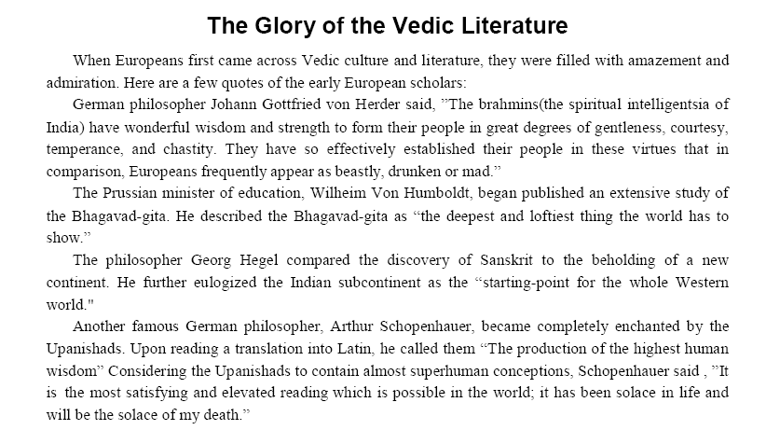
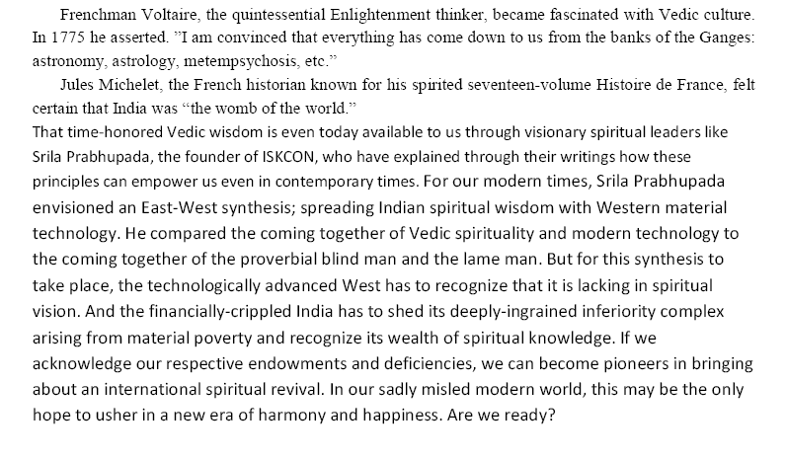

Straight from the Scientists and Sages

As we saw, Vedic literatures are not random baseless ramblings of an amalgamated set of tribes who migrated to India a few centuries ago, but are compilations of wise, self-realized souls of the great Vedic culture. These sages formed the intelligentsia of Vedic society and were held in the same esteem as modern scientists. The difference, however, was that these sages acted as transparent mediums to understand, assimilate and transmit perfect knowledge of the Vedas, while modern scientists themselves are groping in the dark for perfect and complete knowledge.

The following table contains a comparative study of the knowledge acquired through the scientific and Vedic systems. Quotes from authorities in the respective fields i.e. the scientists and the sages respectively, have been used to create the study. In the space provided below each quote, write down in your own words what you understand from the quote. At the end of the study, write down your conclusions about both the systems of knowledge after a class discussion.

Point of Comparative Study | What scientists say about  modern science | What sages say about Vedic knowledge
What kind of phenomenon does it study? | “…Science casts the spotlight which it uses to search for knowledge very selectively; in other words, what scientists choose to look at, to try to explain in scientific terms, is rather restricted, rather biased. And the content of science is biased in a materialistic direction. This applies to almost all the sciences, the physical sciences as well as the biological sciences.  The reason is largely due to the fact that it is easier to study quantitatively the behaviour of matter and the grosser aspects of behaviour (both animal and human) than it is to study higher human behaviour where the influence of God might be significant.”  (B. D. Josephson, Nobel Laureate in Physics)  My Understanding:  ___________________________________________  ___________________________________________ | “Complete knowledge includes knowledge of the phenomenal world and the spirit behind it. “  (Bhagavad-gétä 7.2, Purport)  My Understanding:  _________________________  _________________________
How is knowledge acquired in this system? | “Equipped with his five senses, man explores the universe around him and calls the adventure Science.”  (Edwin Powell Hubble in ‘The Nature of Science’)  “Every great advance in science has issued from a new audacity of imagination.”  (John Dewey in ‘The Quest for Certainty’)  My Understanding:  ___________________________________________  ___________________________________________ | “The Vedic system of acquiring knowledge is the deductive process. The Vedic knowledge is received perfectly by disciplic succession from authorities.”  (Çrémad-Bhägavatam 1.9.18, Purport)  “The Vedic knowledge is authorized and is acquired not by experiment but by authentic statements of the Vedic literatures explained by bona fide authorities. Simply by becoming an academic scholar one cannot understand the Vedic statements; one has to approach the real authority who has received the Vedic knowledge by disciplic succession, as clearly explained in the Bhagavad-gétä (4.2).”  (Çrémad-Bhägavatam 2.2.27, Purport)  My Understanding:  _________________________  _________________________
How perfect and complete is the knowledge? | “We and our models are both part of the universe we are describing. ... One might therefore expect it (any physical theory) to be either inconsistent or incomplete. The theories we have so far are both inconsistent and incomplete.”  (Stephen Hawking, theoretical physicist (currently holds Newton’s chair at Cambridge))  My Understanding:  ___________________________________________  ___________________________________________ | “All Vedic knowledge is perfect because it is received directly from God by the paramparä, disciplic succession.”  (Çrémad-Bhägavatam 4.26.7, Purport)  “Vedic knowledge is complete because it is above all doubts and mistakes, and Bhagavad-gétä is the essence of all Vedic knowledge.”  (Bhagavad-gétä, Introduction)  My Understanding:  _________________________  _________________________
Is the knowledge subject to any deficiencies/ shortcomings? |  | “Vedic knowledge is infallible because it comes down through the perfect disciplic succession of spiritual masters, beginning with the Lord Himself. Since He spoke the first word of Vedic knowledge, the source of this knowledge is transcendental. The words spoken by the Lord are called apauruñeya, which indicates that they are not delivered by any mundane person.”  (Çré Éçopaniñad, Mantra 1, Purport)  “The knowledge of the Vedas is knowledge received directly from God, and there is consequently no question of illusion, cheating, mistakes or imperfect senses.”  (Çrémad-Bhägavatam 4.26.7, Purport)  “We accept Kåñëa as our guru. If He is perfect in knowledge, our knowledge is also perfect. As far as we’re concerned, we do not have to be perfect in ourselves, but if we receive knowledge from the perfect, our knowledge is perfect.”  (Science of Self Realization, Chapter 6g: The Tiny World of Modern Science)  My Understanding:  _________________________  _________________________

